Experiment Details

|  |  |
| --- | --- |
| Department Name | Electronics and Telecommunication |
| Class | BTech |
| Semester | VII |
| Subject Name | Power Electronics |
| Experiment No. | 1 |
| Experiment Name | Study V-I characteristics of SCR |

Version History

|  |  |  |  |  |
| --- | --- | --- | --- | --- |
| Sr. No. | Version Number | Created By | Approved By | Date |
| 1 | v1.0 | Muskan Sameer Vantmori | Sonal Lad | 10/10/2020 |
|  |  |  |  |  |

AIM:

To study and plot the characteristics of SCR

THEORY:

SCR is a four-layered PNPN switching device having three junctions and three terminals known as Anode, Cathode and Gate terminals. When the end P-layer is made positive with respect to the end N-layer, the two outer junctions J1 & J3 are forward biased but the middle layer is reversed biased. Thus the junction J2 because of the presence of depletion layer does not allow any current to flow through the device. Only leakage current negligibly small in magnitude flows through the device due to the drift of the mobile charges. This current is insufficient to make the device conduct. The depletion layer mostly of immobile charges does not conduct. This is called forward blocking state of the device.

On reverse biased conduction, J1 & J3 are reverse biased while J2 is forward biased. The junction J1 & J3 do not allow any current to flow through the device. Only very small leakage current flows through the device. This is known as reverse blocking state or off state of the device.

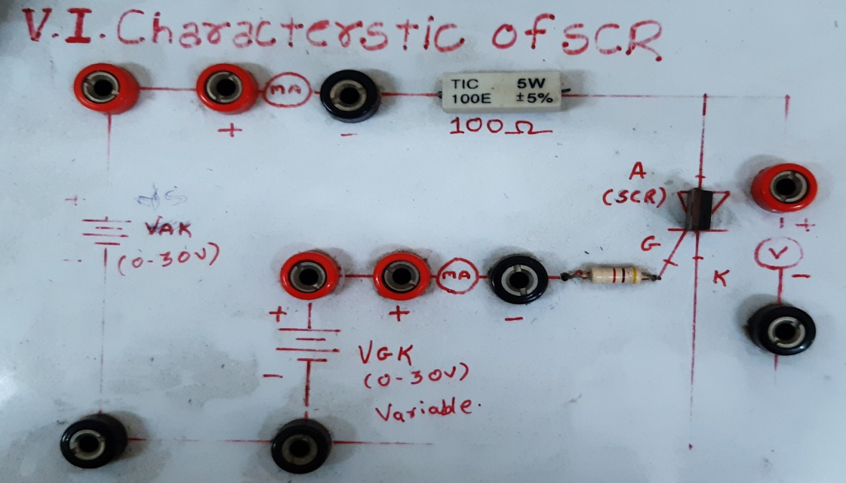

PRE TEST:

1. How many junction/s do a diode consist?  
   a) 0  
   b) 1  
   c) 2  
   d) 3

Ans: b)

1. If the positive terminal of the battery is connected to the anode of the diode, then it is known as  
   a) Forward biased  
   b) Reverse biased  
   c) Equilibrium  
   d) Schottky barrier

Ans: a)

1. What is the value of kT at room temperature?  
   a) 0.0256eV  
   b) 0.25eV  
   c) 25eV  
   d) 0.0025eV

Ans: a)

Explanation: kT=1.38*10-23*300K  
=4.14*10-21/ (1.6*10-19)  
=0.0256eV.

1. The tendency of charge carriers to move from a region of heavily concentrated charges to region of less concentrated charge is known as.  
   a) Depletion current  
   b) Drain current  
   c) Diffusion current  
   d) Saturation current

Ans: c)

1. The tendency of charge carriers to move from a region of heavily concentrated charges to region of less concentrated charge is known as.  
   a) Depletion current  
   b) Drain current  
   c) Diffusion current  
   d) Saturation current

Ans: c)

PROCEDURE:

1) Study the circuit given on front panel of kit.

2) Adjust anode voltage to minimum

3) Adjust gate current to 3.25mA.

4) Keeping gate current constant increase Vs  in steps to note anode- cathode current IA and VAK, for each step till SCR fires.

5) Plot SCR characteristics between IA & VAK .

POST TEST:

1. SCR has terminals called:
2. Anode, cathode
3. Anode, cathode and gate
4. Anode, drain and supply
5. Emitter, base and collector

Ans: b)

1. Choose the false statement
2. SCR is a bidirectional device
3. SCR is a controlled device
4. In SCR the gate is the controlling terminal
5. SCR are used for high-power applications

Ans: a)

1. The static V-I curve for the SCR is plotted for
2. Ia (anode current) vs Ig (gate current), Va (anode – cathode voltage) as a parameter
3. Ia vs Va with Ig as a parameter
4. Va vs Ig with Ia as a parameter
5. Ig vs Vg with Ia as a parameter

Ans: a)

1. SCR will turn on under this condition:
2. The cathode is +ve, Anode is –ve and 0V at the gate
3. The cathode is -ve, Anode is +ve and 0V at the gate
4. The cathode is +ve, Anode is –ve and +ve voltage applied at the gate
5. The cathode is -ve, Anode is +ve and +ve voltage applied at the gate

Ans: d)

1. After turn on ___ will cause it to turn off
2. Gate control
3. Holding current

Ans: b)

REFERENCES:

Text Books:

1 P.S.Bhimbra :Power Electronics

2. P.C.Sen: Power electronics; MGH publication

Reference Books:

1 Ned Mohan: Powerelectronics; WileyPub. 3rd Edition

2. Mohammad Rashid : Power electronics 3rd edition Pearson Publication